**REST - Country Web Service**   
  
Write a REST service that returns India country details in the earlier created spring learn application.  
  
**URL**: /country  
**Controller**: com.cognizant.spring-learn.controller.CountryController  
**Method Annotation**: @RequestMapping  
**Method Name**: getCountryIndia()  
**Method Implementation**: Load India bean from spring xml configuration and return  
**Sample Request**: http://localhost:8083/country  
**Sample Response**:

{

  "code": "IN",

  "name": "India"

}

SME to explain the following aspects:

* What happens in the controller method?
* How the bean is converted into JSON reponse?
* In network tab of developer tools show the HTTP header details received
* In postman click on "Headers" tab to view the HTTP header details received

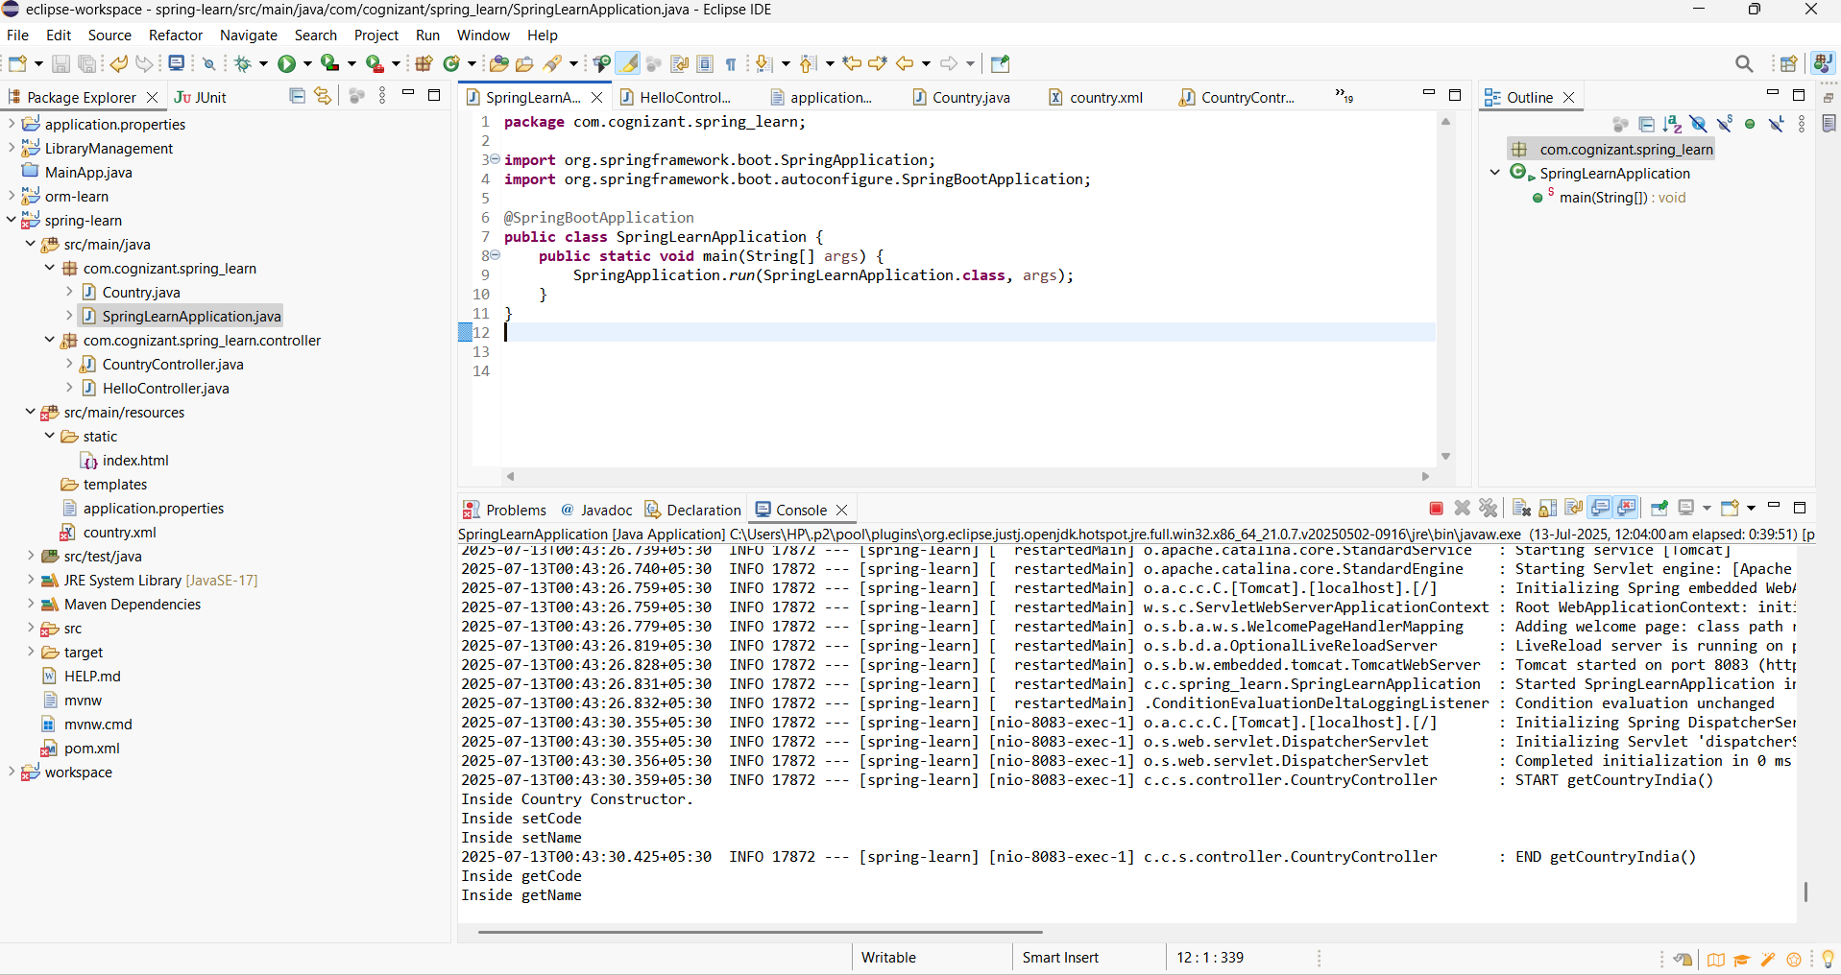

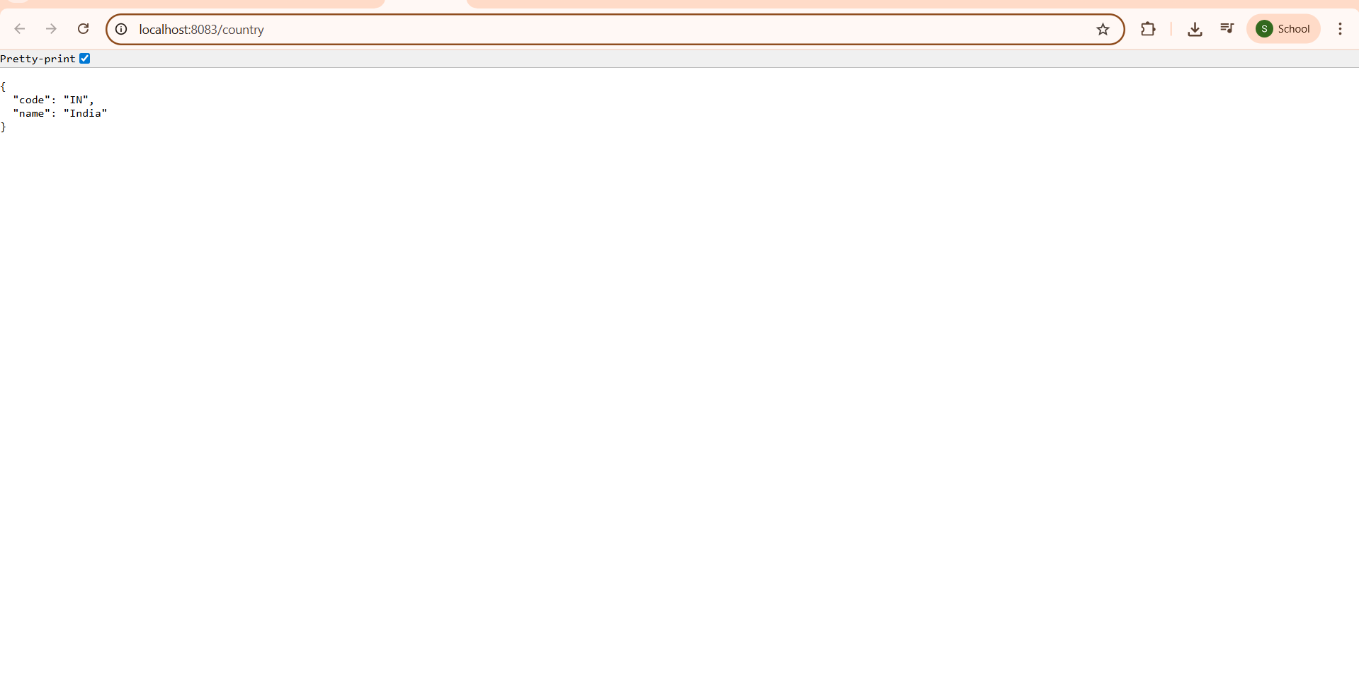

### ✔ What happens in the controller method?

When the endpoint /country is hit:

The controller method is invoked.

It loads the Spring context from country.xml.

It fetches the bean with ID country (which is pre-configured with India’s details).

It returns the bean.

### ✔ How is the bean converted to JSON?

Spring Boot uses **Jackson** (automatically included) to convert Java objects into JSON.

The @RestController and @RequestMapping combination triggers this auto-conversion.

The returned Country object is converted by the **HttpMessageConverter** (Jackson behind the scenes).

